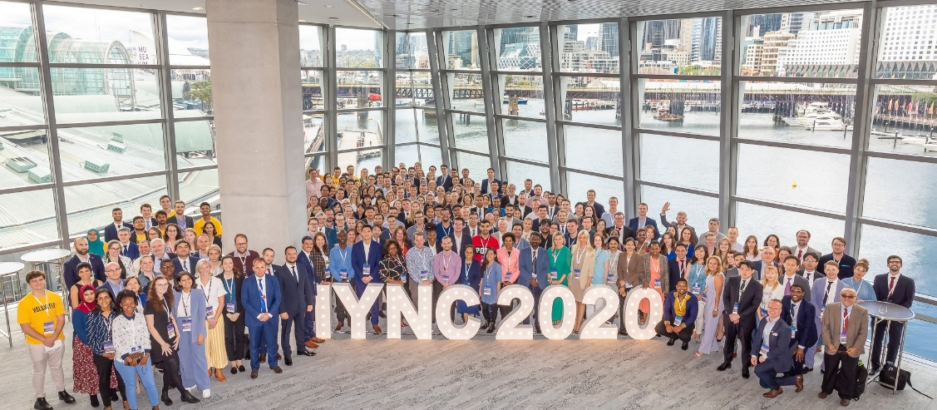
International Young Nuclear Congress – 2020 Sydney Australia
The International Young Nuclear Congress is a unique event that gathers young professionals pursuing their careers in the field of nuclear science. The congress provides a platform for interactions between participants with different professional and cultural backgrounds particularly in sharing knowledge and ideas related to the peaceful uses of nuclear technology.
In 2020, the conference was held in Sydney, Australia between 8-13 March with the theme “Diversity in Nuclear”. Diversity manifested in many different forms during the congress. Diversity in gender was celebrated already on the first casual kick-off day in the frame of International Women’s day. The coincidence of these two events offered excellent opportunity for reunion and networking between WiN members as well as gave room for promotion among young professionals who have not yet been familiar with WiN community. Win members were present from France, Italy, Russia, South Africa, Taiwan, Bangladesh, Australia and several other countries.
Young professionals coming from more than 40 different countries, speakers from 6 continents and Young Generation Networks present from over 19 counties showcased cultural, educational and geographical diversity. Among the speakers, there were IAEA representatives, engineers from start-up companies, renowned university professors, experienced consultants, CEOs, managers and governmental delegates. These experts shared their proficiency in plenary sessions such as “Nuclear for food security”, “Research Reactors”, “Frontiers of Nuclear Medicine”, “Nuclear for Power” and several others reflecting the large variety of nuclear applications.
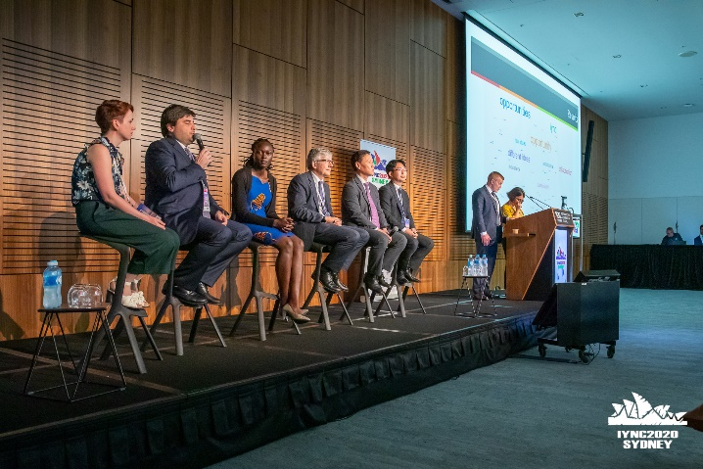  1 First Plenary session with keynote: Diversity in nuclear | 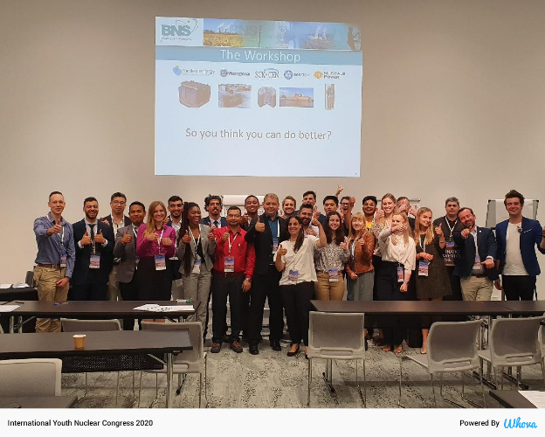  2 Workshop participants on "Design your own reactor"
Interactive workshops were another outstanding element of the congress. During these workshops, attendees in small groups were engaged to work collectively on a particular subject related to current challenges of nuclear technology. Creativity and innovation were encouraged in the development of new ideas and solutions based on the individual experience and knowledge of the group members. The best workshop title was awarded to “Challenges on NPP Construction in Emerging Nuclear Countries” competing with “Design your own reactor”, “Building a Smart Energy Mix”, “Sustainable and Ethical Uranium Mining” and others.
The mentoring programs, aimed to further boost networking, development and capitalize on career opportunities, provided room for diversity in generations. During the mentoring sessions, participants had the chance to benefit from one-on-one conversations with renowned experts from industry, research and academic field as well.
Besides the technical presentations and posters, the congress held numerous technical tours and cultural activities. Thanks to the large variety of nuclear applications in Australia, participants could choose to visit the famous Ranger Uranium Mine (unfortunately, it was cancelled due to the coronavirus situation), the cyclotron and PET camera in the Liverpool Hospital, the site of the Australian Nuclear Science and Technology Organisation, the OPAL and the decommissioned HIFAR research reactors or the Australian Synchrotron. Cultural activities included the welcome dinner at the Wildlife Sydney Zoo with some of Australia’s famous animals (koalas, crocodiles, snakes and spiders), a Harbour Cruise under the iconic Harbour Bridge and past the Sydney Opera House, an ancient aboriginal Smoking Ceremony, surfing lessons at the popular Bondi Beach, casual networking events in the historical district of Sydney and Farewell dinner.
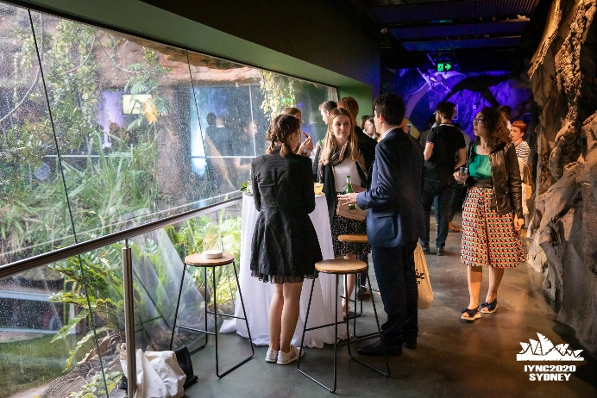 | 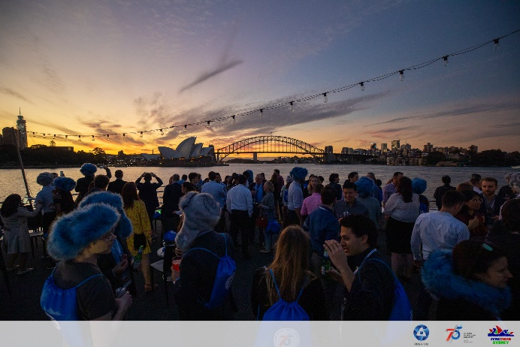
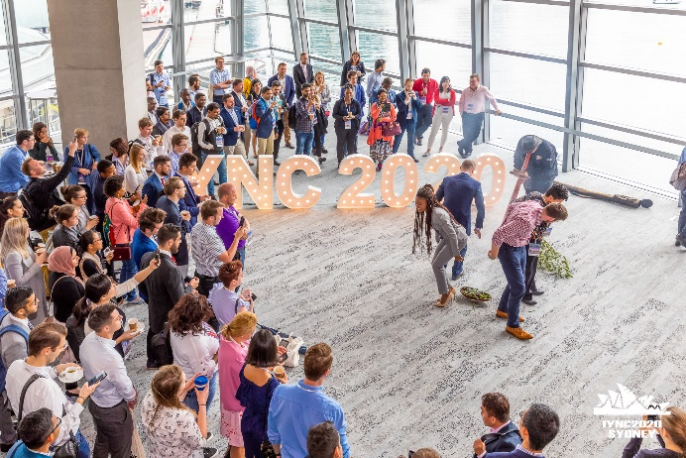 | 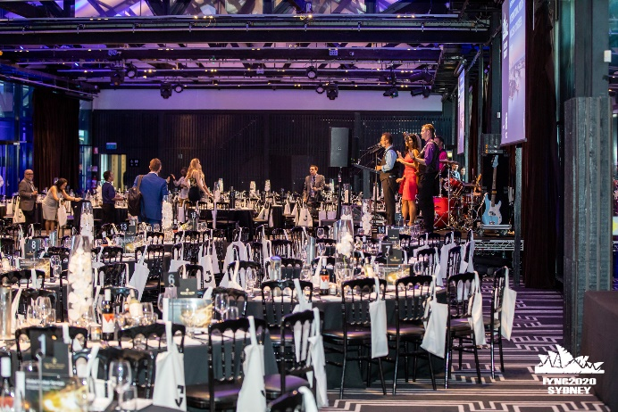
The next IYNC will take place in Russia in 2022 under organization of Russian Young Generation Network.
